UC San Diego | Division of Arts and Humanities | Music

Concert Title

Date – time [e.g. October 5, 2016 – 7 p.m.]

Location

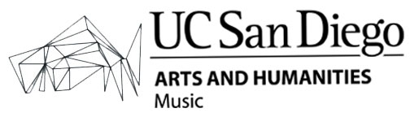

Work #1 (date) Composer (years alive)

Work #2 (date) Composer (years alive)

Intermission

Work #3 (date) Composer (years alive)

Work #4 (date) Composer (years alive)

music.ucsd.edu | Box Office: 858.534.3448



Work #1 (date)

This text should comprise of all notes for the first piece in the program. Repeat this structure for all works with program notes, in the order that they are to be performed.

The text used throughout this template is Brix Sans, the approved font of UC San Diego.

Work #2 (date)

Repeat above.

music.ucsd.edu | Box Office: 858.534.3448

UC San Diego | Division of Arts and Humanities | Music



PERFORMER NAME

Include approved bios for all performers participating in the concert. Use performer’s full name on first mention, then use either first or last name throughout the rest of the bio. Whichever you choose (first or last), please remain consistent throughout the program for each performer listed.

PERFORMER NAME

Repeat above.

music.ucsd.edu | Box Office: 858.534.3448

UC San Diego | Division of Arts and Humanities | Music



PERFORMER NAME

Continue program notes/performer bios as needed.

Audience members are reminded to please silence all phones and noise-

generating devices before the performance. As a matter of courtesy and

copyright law, no unauthorized recording or photography is allowed in the hall.

UC San Diego is a non-smoking campus.

music.ucsd.edu | Box Office: 858.534.3448

UC San Diego | Division of Arts and Humanities | Music